  Special Thanks from  The Jones Family  Anytown, USA  Summer 2006 2006  er 2006 |   Special Thanks from  The Jones Family  Anytown, USA  Summer 2006
  Special Thanks from  The Jones Family  Anytown, USA  Summer 2006 | 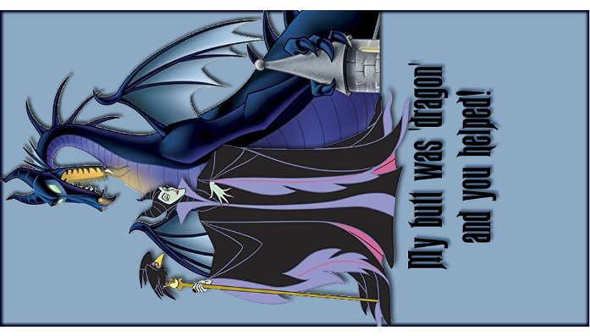  Special Thanks from The Jones Family  Anytown, USA, Summer 2006
  You made our day!  The Jones Family  Anytown, USA  Summer 2006 |   Special Thanks from  The Jones Family  Anytown, USA  Summer 2006
  Special Thanks from  The Jones Family  Anytown, USA  Summer 2006 | 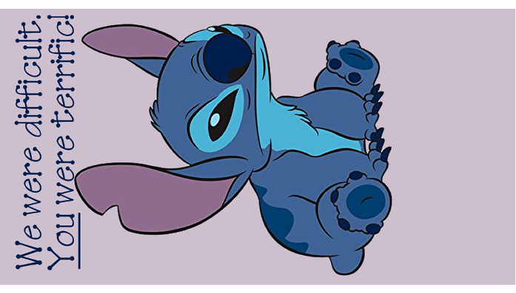  Special Thanks from  The Jones Family  Anytown, USA  Summer 2006
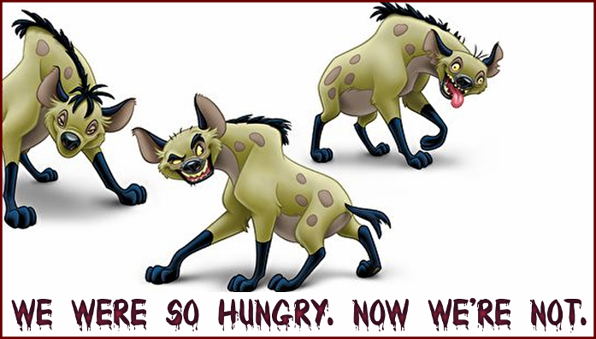  Special Thanks from  The Jones Family  Anytown, USA  Summer 2006 |   Special Thanks from The Jones Family  Anytown, USA Summer 2006

